

**MIT-WORLD PEACE UNIVERSITY, PUNE**



**APPLIED MECHANICS I N D E X**

|  |  |  |  |  |
| --- | --- | --- | --- | --- |
| **Sr.**  **No.** | **Name of the Experiment** | **Page** | **Date** | **Signature of Batch I/C** |
| 1 | Determination of support reaction of simple and compound beams | 1 | 07/09/2021 |  |
| 2 | Determination of Coefficient of friction between flat belt and pulley | 13 | 08/09/2021 |  |
|  |  |  |  |  |
|  |  |  |  |  |
|  |  |  |  |  |
|  |  |  |  |  |
|  |  |  |  |  |
|  |  |  |  |  |
|  |  |  |  |  |
|  |  |  |  |  |
|  |  |  |  |  |
|  |  |  |  |  |



**CERTIFICATE**

##### Certified that Mr./Ms. Krishnaraj Prashant Thadesar of Class **F.Y.B. Tech.** Division 9 Roll No.109054 has completed the laboratory work in the subject **Applied Mechanics** in during the trimester I/II/III of the academic year 2021.

**Signature of the Faculty Seal of the Head of the Department**





Name: Krishnaraj Prashant Thadesar . Class: F.Y B.Tech Division 9 . Batch: I3 .

Roll No.: 109054 Expt. No. 1 .

Performed on: 05/09/2021. Submitted on: 07/09/2021 . Teacher’s Sign.: .

**DETERMINATION OF SUPPORT REACTION OF SIMPLE AND COMPOUND BEAMS**

*Purpose of the experiment:*

To introduce and develop understanding of the basic principles of static equilibrium, types of force systems and various types of transverse loads on determinate beams. To introduce the analytical and experimental methods for determining the reactions of simple and compound beams.

*Materials Required:*

1. Weights
2. Hangers
3. Beams with a spring balance

*Theory:*

Force:

It is defined as a vector quantity that tends to produce an acceleration of a body in the direction of its application. Changing the body's velocity causes the body to accelerate. Therefore, force can be mathematically defined as given by Newton's second law of motion.

$$F=ma$$

Newton’s First law:

A body at rest remains at rest or, if in motion, remains in motion at constant velocity unless acted on by a net external force. This law is the basis of all equilibrium considerations in mechanics.

Force law of equilibrium:

When all the forces that act upon an object are balanced, then the object is said to be in a state of equilibrium. The forces are considered to be balanced if the rightward forces are balanced by the leftward forces and the upward forces are balanced by the downward forces. This however does not necessarily mean that all the forces are *equal* to each other.

Moment of force

The Moment of a force is a measure of its tendency to cause a body to rotate about a specific point or axis. This is different from the tendency for a body to move, or translate, in the direction of the force.

In order for a moment to develop, the force must act upon the body in such a manner that the body would begin to twist. This occurs every time a force is applied so that it does not pass through the centroid of the body.

Moment $τ$ can be defined as

$$τ=F×r$$

Equilibrium

Knowledge of the forces required to maintain an object in equilibrium is essential in understanding the nature of bodies at rest and in motion. To determine if a body is in equilibrium, the overall effect of all the forces acting on it must be assessed. All the forces that act on an object result in essentially one force that influences the object's motion. The force which results from all the forces acting on a body is defined as the net force.

Since an object in equilibrium is considered to be in a state of balance, it can be surmised that the net force on the object is equal to zero. That is, if the vector sum of all the forces acting on an object is equal to zero, then the object is in equilibrium.

The first condition of equilibrium, a consequence of Newton's first law, may be written in vector form*, "A body will be in translational equilibrium if and only if the vector sum of forces exerted on a body by the environment equals zero."*

For example, if three forces act on a body it is necessary for the following to be true for the body to be in equilibrium.

F1 + F2 + F3 = 0 or Σ F = 0

This condition applies to objects in motion with constant velocity and to bodies at rest or in static equilibrium.

Rigid Body in Equilibrium:

A rigid body is in equilibrium when it is not undergoing a change in rotational or translational motion. This equilibrium requires that two conditions must be met. The forces acting on it must add up to zero, and the moments must also add up to zero. It can be represented as:

$ΣF=0$& $ΣM=0$

Beams

Beam is a horizontal member used to carry vertical load, shear load and sometime horizontal load. It is the major component of building structures. It mainly used in construction of bridges, trusses, and other structures which carry vertical load.

* It always rests on supports that we call columns, which is associated with the foundation.
* Beams are the horizontal members, while the columns are vertical members.
* Above the beam, there will be a load.
* Example: A bridge, the horizontal part is the beam, the pillars are the columns, and the cars are the loads.
* The beam transfers the load to the columns vertically. The column then transfers the load to the earth. Due to this you get a reaction force from the ground.

Types of beams:

1. Simply supported beams:

A simply supported beam is one that rests on two supports and is free to move horizontally. Typical practical applications of simply supported beams with point loadings include bridges, beams in buildings, and beds of machine tools.

1. Compound Beams:

Compound beams are structures composed of two or more elements connected by an internal connection. Beam formed by connecting two or more sections or placed together to form a single beam

Reactions and resultants:

Structural components are usually held in equilibrium by being secured to rigid fixing points these are often other parts of the same structure. The fixing points or supports will react against the tendency of the applied forced loads to cause the member to move. The forced generated by the supports are called reactions.

The resultant of a system of forces and couples is the simplest system which can replace the original forces system without altering the external effect on the rigid body to which the forces are applied.

Co-planar force System:

Coplanar force system refers to the number of forces which remain in same plane. This force system can be concurrent, parallel and non-concurrent and non-parallel.

Types of coplanar Forces

1. Parallel: The concurrent coplanar force system refers to the number of forces which are parallel to each other with their lines of action.
2. Concurrent: The concurrent coplanar force system refers to the number of forces which [interest](https://www.chegg.com/learn/accounting/precalculus/interest-in-precalculus) at a common point with their lines of action.
3. Non-Concurrent non-parallel: Non-concurrent and non-parallel coplanar force systems refer to the number of forces which are not parallel and do not lie at the common point with their lines of action

Types of Supports

1. Roller Support-

It is a support which is free to rotate and translate along the surface on which they rest. The surface on which the roller supports are installed may be horizontal, vertical, and inclined to any angle.

* + The roller supports has only one reaction, this reaction acts perpendicular to the surface and away from it. The reaction offered by the roller support is shown in the figure given above.
  + The roller supports are unable to resists the lateral loads (the lateral loads are the live loads whose main components are horizontal forces). They resist only vertical loads.
  + The best example of roller support is the roller skates. The roller skates resist the vertical loads of the persons standing on it. When the lateral loads are applied by the persons, then it starts translating. The translation is due to its inability to resists the lateral loads.

For A roller support, there is only 1 reaction force. The vertical one.

1. Pinned or Hinged Support -

It is a type of support which resists the horizontal and vertical loads but is unable to resists the moment.

* + The pinned support has two support reactions and these are vertical and horizontal reactions. It allows the structural member to rotate but does not allow translating in any direction. The pinned support allows the rotation only in one direction and resists the rotation in any other direction.
  + The reactions of the pinned support are shown in the figure given above.
  + The pinned support is also known as hinge support.
  + The best example where we can see the pinned support is the doors and windows of our houses and our knee joint. Here the rotation happens in one direction but the translation motion is restricted.

1. Fixed Support -

It is a support which is capable of resisting all types of loads i.e., horizontal, vertical as well as moments. The fixed support does not allow the rotation and translation motion to the structural members.

* + The fixed support is also called as rigid support.
  + The reactions acting in the fixed support is shown in the figure given above.
  + A flagpole fixed in the concrete base is the best example of fixed support. The other examples of the fixed support are electric pole in the streets, a bracket on the wall, and all the riveted and welded joints in the steel etc.
  + It provides the greater stability to the structure as compared with all other supports.

Types of Loading Systems

1. Concentration or point load: A point load is an equivalent load applied to a single point, which you can determine by calculating the total load over the object’s surface or length and attributing the entire load to its center.
2. Distributed load: A distributed load is a force spread over a surface or line, which can be expressed in terms of force per unit area, such as kilonewtons (kN) per square meter. Distributed load is that acts over a considerable length. Distributed load is measured as per unit length.
   1. Uniform Uniformly distributed load is that whose magnitude remains uniform throughout the length.
   2. Uniformly Varying load: It is that load whose magnitude varies along the loading length with a constant rate.

*Procedure:*

1. Place a wooden beam horizontally with one of its ends resting on the pan balance.
2. Note down the initial reading shown by the pan.
3. Attach an external load to the hanger at a distance x from the pin support.
4. Note the final reading shown b the pan balance due to self-weight and external load. (W)
5. From the final reading, subtract the initial reading to get the reaction due to the external load.
6. Calculate the value of the reaction mathematically and then compare it with the experimental value
7. Repeat the above procedure for the arrangement of a compound beam shown in the figure.



***Observations and Calculations*: -**

1. Simple Beam: Span of the beam (L) = m

|  |  |  |  |  |  |  |  |
| --- | --- | --- | --- | --- | --- | --- | --- |
| Sr.  No. | Load ‘W’ (N) | Distance ‘x’ (m) | RB Experimentally (N) | | | RB  Analytical  (N) (RB)Ana  *Wx*  =  *L* | % Error =  ⬆*RB* *Exp*  *RB* *Ana *  ⬇ *R*  100   *B Ana* ✗ |
| Due to Self-Weight (N) | Due to External Load + Self Weight (N) | RB due to External Load (N)  (RB)Exp |
| 1 |  |  |  |  |  |  |  |
| 2 |  |  |  |  |  |  |  |
| 3 |  |  |  |  |  |  |  |
| 4 |  |  |  |  |  |  |  |
| 5 |  |  |  |  |  |  |  |

Fig. 1. Simple Beam

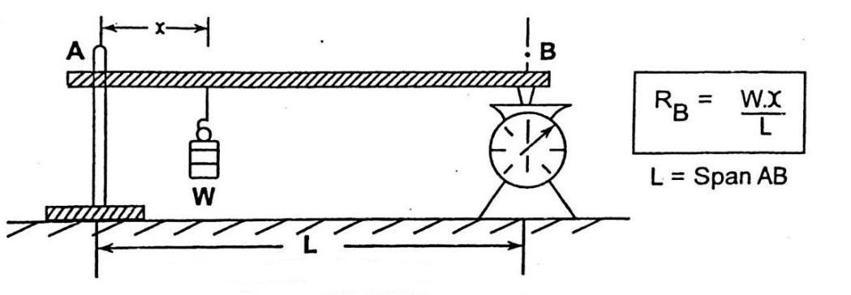



1. Compound Beam

Span of beam AB = L1 = m Span of beam CD = L2 = m Distance ‘a’ = 0.2 m

|  |  |  |  |  |  |  |  |
| --- | --- | --- | --- | --- | --- | --- | --- |
| Sr. | Load | Distance | Rc Experimentally (N) | | | Rc | % Error =  ⬆*RB* *Exp*  *RB* *Ana*   ⬇ *R*  100   *B Ana* ✗ |
| No. | ‘W’ (N) | ‘x’ (m) |  | | | Analytical  (N) (Rc)Ana |
| Due to Self  Weight (N) | Due to External Load  + Self Weight (N) | Rc due  to |
|  |  |  |  |  | Externa | *Wx**L*2  *a* |
|  |  |  |  |  | l Load | *L*1 *L*2 |
|  |  |  |  |  | (N) |  |
|  |  |  |  |  | (Rc)Exp |  |
| 1. |  |  |  |  |  |  |  |
| 2. |  |  |  |  |  |  |  |
| 3. |  |  |  |  |  |  |  |
| 4. |  |  |  |  |  |  |  |
| 5. |  |  |  |  |  |  |  |

Note: Students are instructed to do all the necessary calculations on separate sheets.

**Figure 2. Compound Beam**

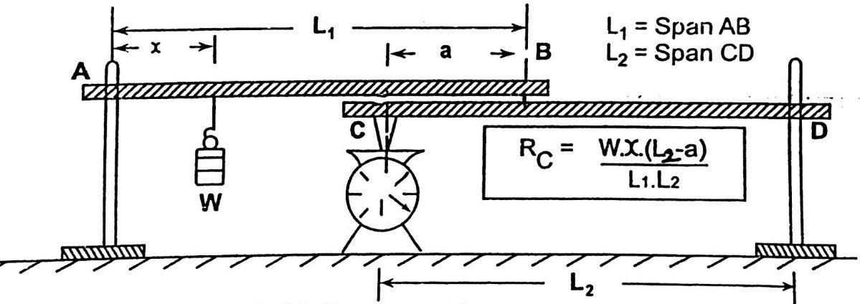

*Conclusion*: -

Thus, we now know that formula for simple beam reaction is

$$R= \frac{Wx}{L}$$

where L is span of the Beam.

Similarly, we find the formula for compound beam reaction which is

$$R=\frac{WX(L2-a)}{L1.L2}$$

where L1 is the span of one beam and L2 is the span of the other beam.

*Questions: -*

* 1. What is meant by equilibrium of a force system? What are the physical and analytical conditions of equilibrium?
  2. What are the different types of supports and their corresponding reactions?
  3. What do you mean by udl & uvl?
  4. What is a compound beam? Illustrate by an example.
  5. What is meant by F.B.D. of a body?

*Answers: -*

1. A body is said to be in equilibrium if the resultant of all forces acting on the body is zero.  
   Physical and analytical conditions for a body to be in equilibrium –  
   1) The sum of all external forces acting on the body is zero  
   2) The sum of all external torques from external forces is zero
2. The different types of supports are roller, pinned and fixed support corresponding reactions:
   1. Roller support - Roller supports only resists perpendicular forces and they cannot resist parallel  
      or horizontal forces and moment.
   2. Pinned support - Pinned support or hinged support can resists both vertical and horizontal  
      forces but they cannot resist moment
   3. Fixed support - Fixed supports are also called as rigid supports. They are restrained against  
      both rotation and translation so they can resist any type of force or moment.
3. UDL - Uniformly distributed load: Load is distributed uniformly throughout a given length or beam.  
   UVL - Uniformly varying load: Load distribution varies throughout a given length or beam.
4. Compound beam: A timber beam or rafter built up from a number of pieces.
5. A free body diagram (force diagram, or FBD) is a graphical illustration used to visualize the  
   applied forces, moments and resulting reaction on a body in a given condition.